EXPERIMENT – 3
BASIC IMAGE OUTLINE DETECTION USING CANNY FUNCTION
AIM
To perform basic image handling and processing operations using Python and OpenCV by reading an image and converting the image to show its outline using the Canny function.
REQUIREMENTS
Software Requirements:
• Python 3.x
• OpenCV (cv2)
• Notepad
• Command Prompt
• Windows Operating System
ALGORITHM
- Start the program.
- Import the OpenCV library.
- Read the image using cv2.imread().
- Check whether the image is successfully loaded.
- Display the original image.
- Apply Canny Edge Detection using cv2.Canny().
- Display the edge-detected image.
- Wait for a keyboard key press.
- Close all image windows.
- Stop the program.
PROCEDURE
- Install Python on the computer.
- Install OpenCV using the command pip install opencv-python.
- Create a folder named opencv on the Desktop.
- Place the input image flower.jpg inside the opencv folder.
- Open Notepad and type the Python program.
- Save the program as image_canny.py inside the opencv folder.
- Open Command Prompt.
- Navigate to the opencv folder using the commands cd Desktop and cd opencv.
- Run the program using the command python image_canny.py.
- The original image and Canny edge image will be displayed.

PROGRAM
import cv2
image = cv2.imread("flower.jpg")
if image is None:
print("Image not found")
else:
cv2.imshow("Original Image", image)
edges = cv2.Canny(image, 100, 200)

cv2.imshow("Canny Edge Image", edges)

cv2.waitKey(0)
cv2.destroyAllWindows()
COMMANDS USED
cd Desktop
cd opencv
python image_canny.py
INPUT
The input image used in this experiment is:
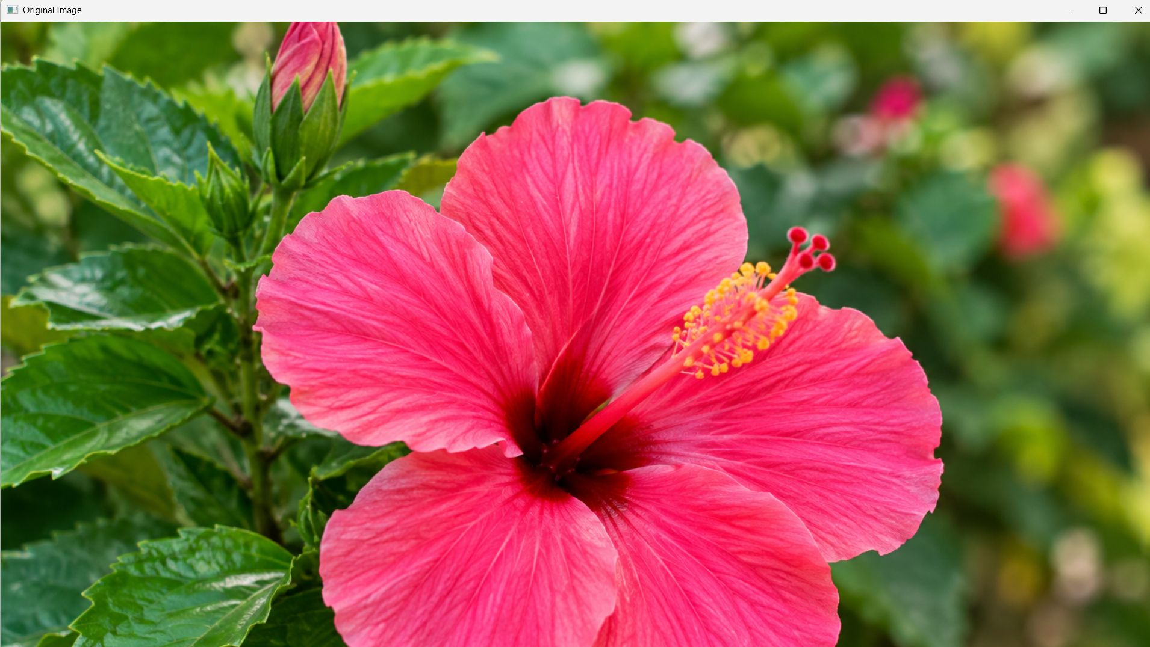
flower.jpg

OUTPUT
The program displays two windows:
- Original Image
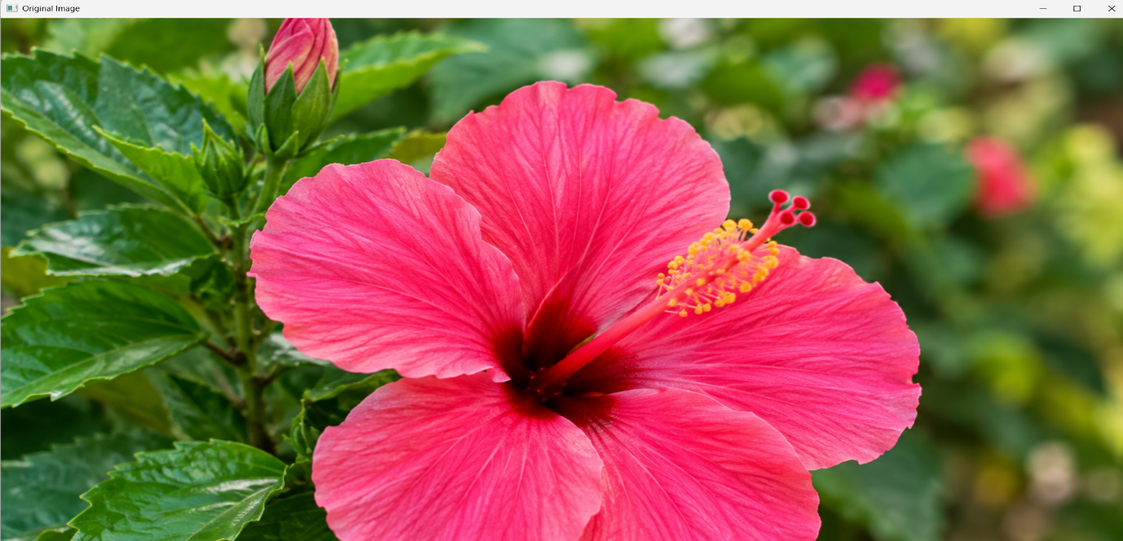
- Canny Edge Image
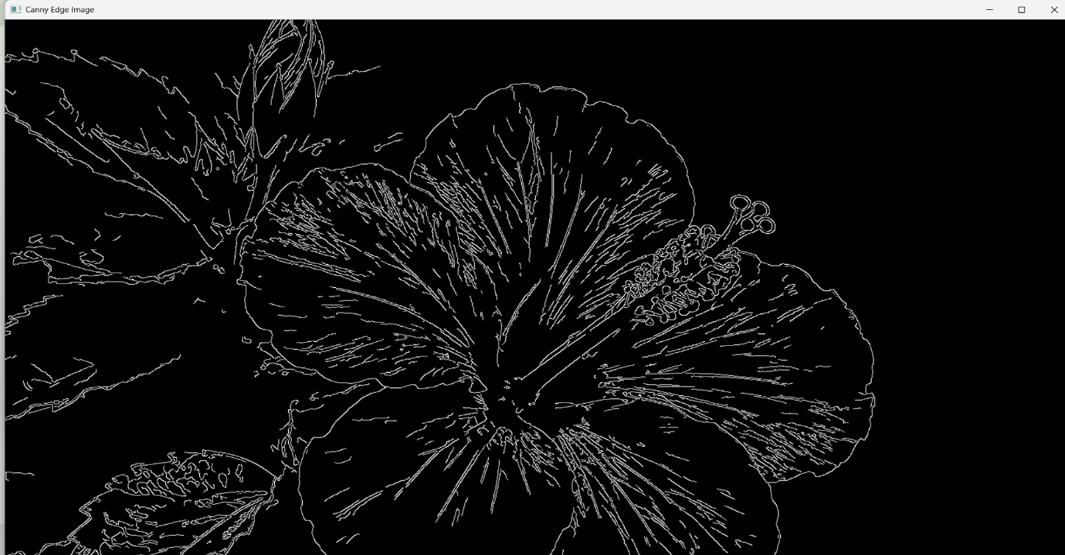
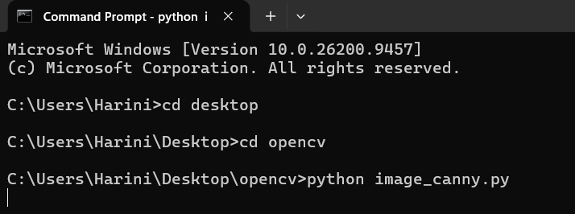
.RESULT
Thus, the given image was successfully read using Python and OpenCV, and the Canny function was successfully used to detect and display the outlines of the image.

